Curve Fitting Methodology
Master of Engineering Project
April 30, 2009

1.) Mortgage originations

- First 24 months: Held mortgage originations at zero
- Next 36 months: Fit curve according to previous historical ramp-up rate

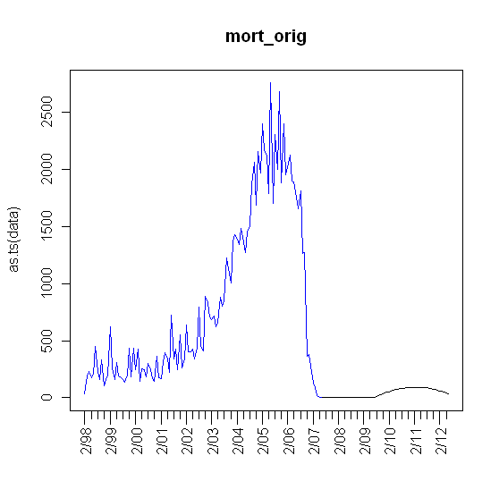
2.) Foreclosures

- Assumption: Recovery in 24 months, as in mortgage originations
- Obtained cumulative foreclosure estimates for 2008-2009 from the “Center of Responsible Lending”

Idaho Original data
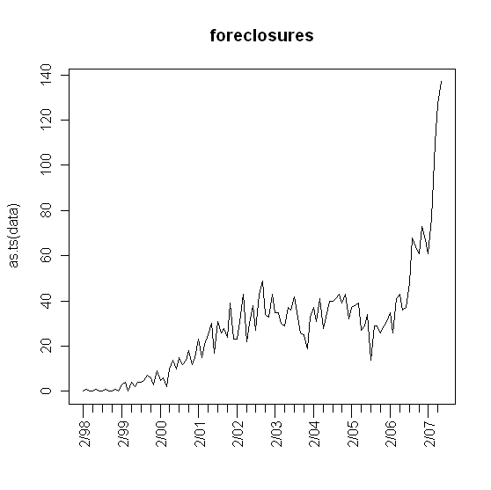

Cumulative foreclosure estimates plot
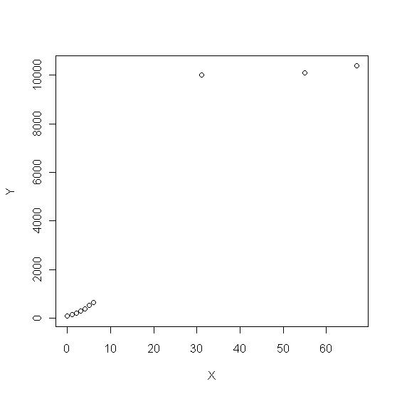

Idaho Foreclosures Forecast

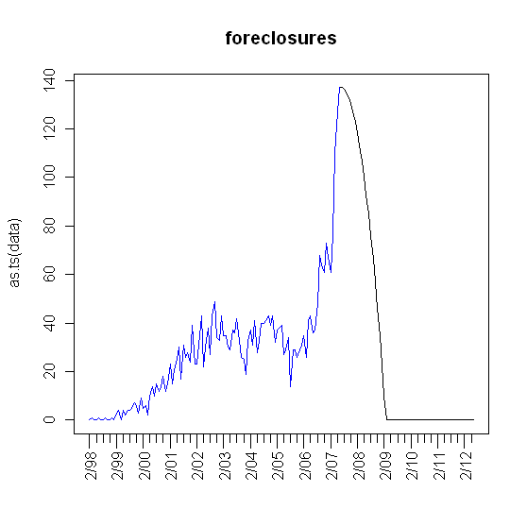

3.) Unemployment Rate

- Assumption: Periodic
- Fit 4th order polynomial using the most recent peak and trough.

Idaho Original data
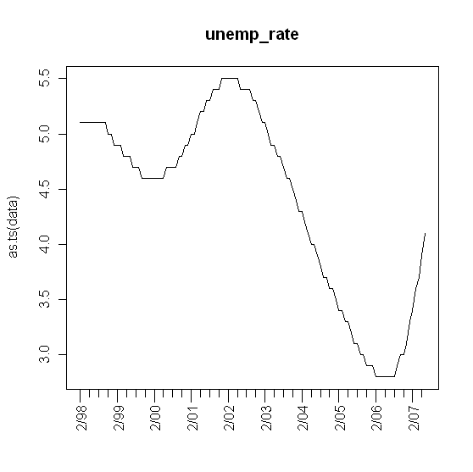
Initialization
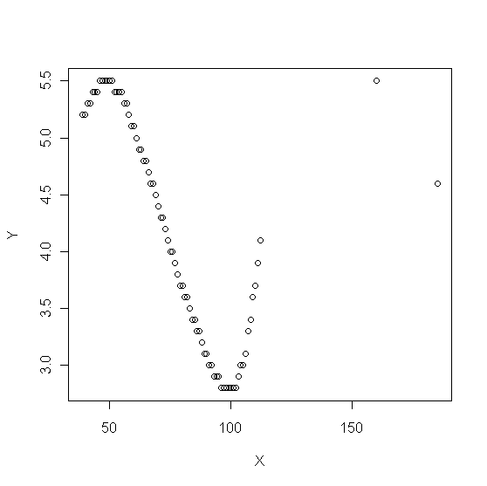

Idaho Unemployment Rate Forecast

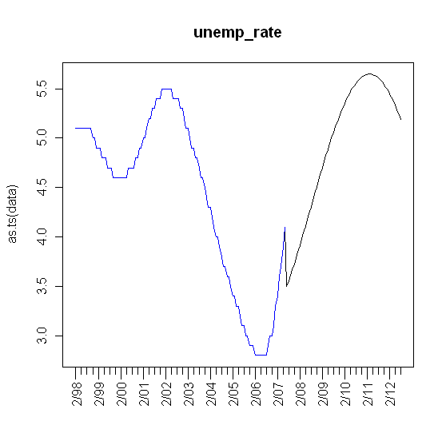

5.) Median income

- Assumption: Stationary about the last 2-year moving mean

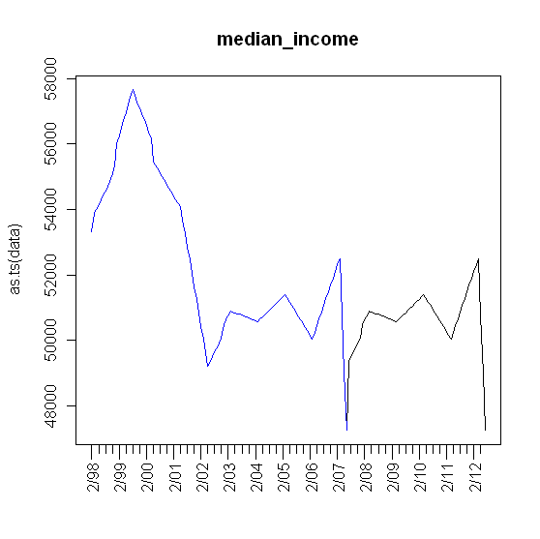
6.) Building permits

- Assumption: Stationary about the pre-bubble mean

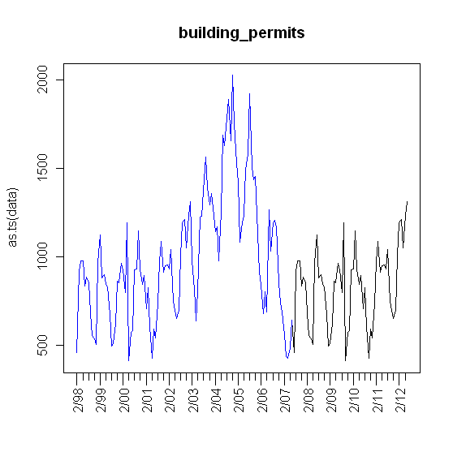
7.) Population size

- Assumption: linear growth based on previous trend

